**Master Functional Document**

|  |  |
| --- | --- |
| **Application** | NGERP - Centra |
| **Service Bundle** | Master Management |
| **Service Request** | Tax Category |

**Description :**

Tax Category Master is Used to Create Tax Category which is mapped to a tax rate in tax rate master. User can also set the default tax category to load in the screens in this master.

**Workflow Process :**

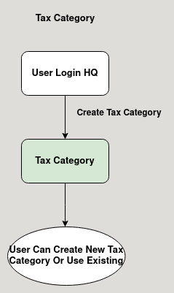

**Business Rules :**

* Tax Category can be only created in HQ.
* The Tax Category Master is used to create tax category.
* Tax Category should be Active to show in the tax category list.
* Tax Category Must be assigned to Tax Rate to calculate Tax.
* Calculation:

Tax amount = Tax Rate/100 * Line amount.

* Note: Tax amount will be calculated for each product in line according to the TAX RATE given.
* Example: for the invoice that has single product and the line amount is 1000 and tax rate is 8% the tax amount is calculated as following
* Tax amount = 8/100 * 1000 = 80
* The Tax amount is 80, then the total invoice amount is 1080.